














AI-Driven Inventory Optimization & Demand-Supply Analysis Using Excel
Project Domain

[
Excel / Power BI with Copilot
]

A Collaborative Initiative

equipping students with practical skills in AI, Data Analytics, and Business Intelligence

b
y:

Institution
:

H.L College of Commerce
[
]

Year
-

2026

Student Name

Palak Narender Kumar
Kotwani

Student Email

Kotwanip065@gmail.com

Guide

R. Umamaheshwari

ACKNOWLEDGEMENT

Completing this project has been a rewarding experience, and it would not have been possible without the guidance and support of several individuals and organizations whom I would like to sincerely thank.

I am deeply grateful to the Edunet Foundation, Microsoft, LinkedIn, and SAP for providing the AICW Fellowship Program—a platform that gave me hands-on exposure to real-world data analytics, business intelligence, and AI tools. The learning resources, structured curriculum, and mentoring opportunities have been invaluable.

I would like to extend my heartfelt thanks to my project guide and mentor for their consistent encouragement, timely feedback, and patient guidance throughout the duration of this project. Their insights helped me navigate complex data challenges and produce meaningful results from the Inventory and Sales dataset.

I am also grateful to my institution for providing the necessary academic infrastructure and a conducive environment for project-based learning. The technical resources made available to me played a key role in the successful execution of this work.

Finally, I wish to acknowledge my family and friends for their unwavering encouragement and support, especially during the moments when things did not go as planned. Their belief in me kept me motivated throughout this journey.

ABSTRACT OF THE PROJECT

This project is part of the AICW (Artificial Intelligence in the Contemporary World) Fellowship Program, a collaborative initiative by Edunet Foundation in partnership with Microsoft, LinkedIn, and SAP. The fellowship equips students with practical, hands-on skills in Artificial Intelligence, Data Analytics, and Business Intelligence tools.

This project focuses on cleaning, analyzing, and deriving actionable insights from a large-scale Inventory and Sales dataset using Microsoft Excel and AI-assisted tools. The dataset comprised 990 product records across 16 fields, spanning 7 major product categories including Fruits & Vegetables, Dairy, Grains & Pulses, Seafood, Beverages, Oils & Fats, and Bakery.

The raw data contained formula-driven columns for order fulfilment status, inventory reorder alerts, and out-of-stock flags, along with attributes such as unit price, sales volume, delivery days, warehouse location, and inventory turnover rate. Key objectives included building a structured data model, computing business-critical KPIs, and identifying inventory performance patterns.

Results revealed that 53.4% of orders were in pending status due to sales demand exceeding available stock, while 46.6% were fulfilled. The average inventory turnover rate stood at approximately 50.15, indicating healthy stock movement overall. Bread Flour emerged as the fastest-moving product with 1,002 units in sales volume, whereas Lettuce was flagged as the slowest-moving item at just 166 units. Fruits & Vegetables dominated the dataset with 331 products and over 19,000 units in total sales.

The project leveraged Excel pivot tables, conditional formulas (IF, COUNTIF, AVERAGE, SUM), and KPI dashboards to synthesize these findings. AI tools were used to support data interpretation and insight generation. The overall experience demonstrated how structured data analysis using accessible tools like Excel, combined with AI assistance, can provide significant value in inventory management decision-making.

TABLE OF CONTENTS

Acknowledgement | 2
Abstract of the Project | 3
List of Figures | 6
List of Tables | 7
Chapter 1 — Introduction | 8
1.1 Problem Statement | 8
1.2 Motivation | 9
1.3 Objectives | 9
1.4 Scope of the Project | 10
Chapter 2 — Literature Survey | 11
Chapter 3 — Proposed Methodology | 13
3.1 System Design | 13
3.2 Modules / Components Used | 14
3.3 Data Flow Diagram (DFD) | 15
3.4 Advantages | 15
3.5 Requirement Specification | 16
Chapter 4 — Implementation and Results | 17
4.1 Data Cleaning Results | 17
4.2 Visualization / Output Results | 18
4.3 AI Tool Integration Results | 19
Chapter 5 — Discussion and Conclusion | 20
References | 23
Appendices | 24

LIST OF FIGURES

Figure No. | Figure Title / Description | Page No.
Figure 1 | DFD Level 0 — Context Diagram of Inventory Analysis System | 14
Figure 2 | DFD Level 1 — Detailed Sub-process Flow | 14
Figure 3 | Raw Inventory Sales Dataset — First 20 rows showing all 16 columns | 16
Figure 4 | Cleaned and Formula-Validated Dataset with Status & Flag Columns | 17
Figure 5 | KPI Dashboard — Turnover Rate, Fulfilment Rate, Delivery Time | 19
Figure 6 | AI Tool (Copilot / ChatGPT) in use for Data Insight Generation | 22

LIST OF TABLES

Table No. | Table Title / Description | Page No.
Table 1 | Raw Dataset Summary — Field Names, Data Types, and Row Count | 17
Table 2 | Cleaned Dataset Summary — Issues Found and Fixes Applied | 17
Table 3 | Hardware Requirements | 17
Table 4 | Software Requirements | 17
Table 5 | Key KPI Results — Inventory Turnover, Fulfilment Rate, Delivery Time | 18
Table 6 | Category-wise Sales & Stock Breakdown | 18
Table 7 | Top 10 Products by Sales Volume (from Pivot Table) | 19

CHAPTER 1 — Introduction

This chapter introduces the project undertaken as part of the AICW Fellowship Program. It presents the background of the problem, the motivation behind pursuing this project, and clearly outlines the objectives and scope. The project is built around a real-world inventory and sales dataset, and uses Microsoft Excel as the primary tool for data cleaning, analysis, and visualization, supplemented by AI-assisted insights.

Problem Statement

“In today’s competitive business environment, effective inventory management plays a critical role in ensuring smooth operations and customer satisfaction. However, many businesses struggle with maintaining the right balance between product demand and available stock. A mismatch between demand and supply often leads to two major issues—stock shortages and overstocking—both of which negatively impact business performance.

In the given inventory and sales dataset, a significant issue has been identified where more than 53% of total orders are in a pending state. This indicates that the available inventory is not sufficient to meet customer demand, reflecting poor inventory planning and inefficient stock allocation. At the same time, the presence of both fast-moving and slow-moving products suggests an imbalance in inventory utilization, where some items are overstocked while others are understocked.

Another major challenge observed is the lack of proper demand forecasting. Businesses are making reactive decisions based on current stock levels rather than predicting future demand trends. This results in delayed replenishment, increased pending orders, and missed sales opportunities. Additionally, although large amounts of data are available, it is not being effectively transformed into meaningful insights for decision-making, indicating a gap in data-driven management practices.

Therefore, there is a strong need to analyze the inventory and sales data using structured tools and techniques to identify key problem areas. By leveraging data analysis and generating actionable insights, businesses can improve order fulfillment rates, optimize stock levels, and make more informed, data-driven decisions to enhance overall inventory performance.”

1.2 Motivation
The motivation to take on this specific project came from a genuine interest in how data — when properly structured and analysed — can transform business decisions. Inventory and supply chain management is a domain where even a small improvement in stock visibility can lead to substantial cost savings and better customer satisfaction.

Working with a dataset that includes real-world complexity — multiple product categories, 350 unique suppliers, varying delivery timelines, and sales volumes ranging from 166 to 1,002 units per product — offered a practical opportunity to apply Excel and AI skills in a meaningful context. The fellowship program’s emphasis on hands-on learning made this the ideal project to demonstrate both technical proficiency and business thinking.

On a broader level, the tools and methodology explored here — Excel pivot tables, conditional formulas, KPI tracking, and AI-assisted interpretation — are widely used in industry, and building competency in these areas has direct professional relevance.

1.3 Objectives
The objectives of this project are outlined below. Each objective is specific, measurable, and directly tied to the activities performed during the project:
- To understand and document the structure of the Inventory Sales dataset, including all 16 data fields, their data types, and the relationships between them.
- To clean and validate the raw dataset by reviewing formula-driven columns
(Fulfilled/Pending status, Reorder Status, Out of Stock Flag) and ensuring they produce accurate and consistent results.
- To calculate and analyse key business performance indicators (KPIs) including Inventory Turnover Rate, Order Fulfilment Rate, Total Orders, and Average Delivery Time.
- To build an Excel Pivot Table summarizing total sales volume by product name, and identify the fastest-moving and slowest-moving products.
- To conduct a category-wise analysis of sales volume and stock levels across the 7 product categories in the dataset.
- To integrate AI tools (Copilot or ChatGPT) to assist with data interpretation, generate business insight summaries, and explore prompt-driven analysis.
- To document findings, limitations, and recommendations in a structured project report following the AICW template guidelines.

1.4 Scope of the Project
The scope of this project is defined as follows:
- The project is based entirely on the Inventory Sales dataset provided (990 rows, 16 columns), covering products across 7 categories: Fruits & Vegetables, Dairy, Grains & Pulses, Seafood, Beverages, Oils & Fats, and Bakery.
- Tools used are limited to Microsoft Excel (with formulas, pivot tables, and data validation) and AI chatbot/Copilot for insight generation and report drafting assistance.
- The analysis focuses on data cleaning, KPI computation, pivot-based summarization, and category-level performance evaluation.
- The project does not include real-time data integration, automated inventory replenishment systems, or predictive machine learning models.
- This is a fellowship showcase project and is not intended as a production-level inventory management system.
- Power BI dashboards are outside the scope of this specific project but may be referenced where applicable as potential enhancements.

CHAPTER 2 — Literature Survey

A literature survey establishes the theoretical and practical foundation for the project. This chapter reviews existing work and research relevant to inventory management, data analysis using Excel, and AI-assisted business intelligence. It also identifies gaps that the current project addresses.

2.1 Existing Work and Research
Inventory management has been a subject of extensive academic and industry research for decades. Early models such as the Economic Order Quantity (EOQ) model and Just-In-Time (JIT) methodology established foundational principles for stock optimization. More recent research has shifted focus toward data-driven approaches, leveraging modern BI tools to extract insights from transactional records.

Studies published in journals such as the International Journal of Production Economics and Supply Chain Management: An International Journal have demonstrated that organizations using structured data analysis for inventory monitoring report up to 25% reductions in stockout events and measurable improvements in order fulfilment rates. These findings directly support the premise of this project.

Research on Excel-based business analytics — particularly pivot tables, conditional formatting, and formula-based classification — has shown that even without advanced BI platforms, Excel remains one of the most widely deployed tools for inventory tracking in small-to-medium enterprises (SMEs). A 2022 Microsoft survey found that over 750 million people use Excel globally, making it the de facto standard for data operations in business contexts.

The integration of AI into data workflows is a more recent development. Research on prompt engineering and AI-assisted analytics (from sources including OpenAI, Anthropic, and Microsoft Copilot documentation) suggests that AI models can significantly reduce the time required for data summarization, pattern identification, and report generation. Studies comparing manual analysis with AI-assisted workflows have reported time reductions of 50–80% for routine data reporting tasks.

2.2 Tools and Technologies Review
The following tools and technologies were reviewed and used as part of this project:

Microsoft Excel
Excel is the world’s most widely used spreadsheet application. For this project, the key features utilized included: structured table formatting (Excel Tables for referencing with Table1[column] syntax), conditional formula logic using IF, COUNTIF, and AVERAGE functions, pivot tables for dynamic product-level summarization, and data validation for consistency checks. Excel’s ability to handle up to 1,048,576 rows makes it well-suited for datasets of this scale.

Pivot Tables
Pivot tables are one of Excel’s most powerful summarization features. The pivot table in this project aggregated sales volume data across all products, enabling quick identification of high-performing and low-performing items without writing complex formulas. Research consistently identifies pivot tables as one of the highest-impact Excel features for business users.

Microsoft Copilot / AI Chatbots (ChatGPT, Gemini)
Generative AI tools have emerged as a powerful complement to traditional data analysis. In the context of this project, AI was used to assist with interpreting ambiguous data patterns, generating written summaries of KPI results, and drafting structured report content. Microsoft Copilot, integrated within Microsoft 365, offers contextual AI assistance directly within Excel and Word, further streamlining the analysis workflow.

Conditional Formulas in Excel
The dataset used in this project contained several formula-driven columns. The IF function was used to classify orders as Fulfilled or Pending based on whether Sales Volume exceeded Stock Quantity. Similarly, reorder status and out-of-stock flags were computed using conditional logic.
These formulas represent a standard pattern in inventory management systems built on Excel.

2.3 Gaps Identified
Based on the literature review, the following gaps were identified that this project addresses:
- Existing literature often focuses on enterprise-grade inventory systems (SAP ERP, Oracle) rather than accessible tool-based approaches using Excel, leaving a gap for SME-level practical solutions.
- There is limited documentation specifically addressing how to compute and interpret all core inventory KPIs (turnover, fulfilment rate, reorder flags) within a single Excel model, particularly for fellowship or academic projects.
- The integration of AI chatbots (rather than just Copilot) for inventory data interpretation and insight generation is underrepresented in existing academic literature, despite its practical utility.
- Most existing projects treat data cleaning and analysis as separate workflows; this project integrates them within a unified Excel-based model using structured table references.

CHAPTER 3 — Proposed Methodology

This chapter outlines the methodology adopted to achieve the project objectives. It covers the overall system design, the functional modules or components used, the data flow through the system, the key advantages of the proposed approach, and the hardware and software requirements.

3.1 System Design
The system design for this project follows a linear data pipeline from raw input to analysed output.
Each stage transforms the data progressively and adds analytical value.

Stage | Description
Data Source / Input | Excel workbook (Palak_kotwani_Inventory_Sales_data.xlsx) containing 990 rows and 16 columns of product inventory and sales data.
Data Review & Validation | Review of column definitions, data types, and formula logic in the Fulfilled/Pending, Status, and Out of Stock Flag columns.
Data Analysis | KPI computation using AVERAGE, COUNTIF, SUM; category-level aggregation; pivot table construction for product-level sales summary.
Insight Generation | Identification of top/bottom performing products, category performance comparison, reorder analysis.
AI Integration | Use of Copilot / AI chatbot to assist with summarizing findings and generating written insights.
Output | Structured KPI dashboard, pivot table output, project report with conclusions and recommendations.

3.2 Modules / Components Used
The project is organized into five functional modules, each addressing a specific aspect of the analysis:

Module 1 — Data Ingestion and Structure Review
The raw dataset was loaded into Excel and reviewed for structure. Column headers were verified, data types were checked, and the Excel Table (Table1) format was confirmed to be properly applied, allowing structured column references in formulas.

Module 2 — Data Validation and Formula Audit
Each formula-driven column was reviewed individually. The Fulfilled/Pending column used an IF formula comparing Sales Volume against Stock Quantity. The Status column flagged items requiring reorder when stock fell at or below the Reorder Level. The Out of Stock Flag identified products with zero stock. All formulas were verified to be correctly applied across all 990 rows.

Module 3 — KPI Computation (KPI Sheet)
A dedicated KPI sheet was built to surface six critical business metrics: Inventory Turnover Rate (average), Orders Fulfilled (count), Orders Pending (count), Total Orders, Average Delivery Time, and Order Fulfilled Rate. These metrics provide a snapshot of the inventory system’s health at a glance.

Module 4 — Pivot Table Analysis
A pivot table was constructed on a separate sheet summarizing the Sum of Sales Volume grouped by Product Name. This allowed identification of the fastest-moving product (Bread Flour — 1,002 units) and slowest-moving product (Lettuce — 166 units), along with the Grand Total of 58,336 units across all products.

Module 5 — AI Integration and Insight Generation
AI tools were used in this phase to help interpret the computed KPIs, summarize category-level performance, and assist in drafting written insights for the report. Prompts were designed to extract specific business conclusions from the numerical outputs.

3.3 Data Flow Diagram (DFD)

DFD Level 0 — Context Diagram
At the highest level, the system can be described as a single process: Raw Inventory & Sales Data flows into the Excel Analysis System, which outputs a Cleaned Dataset, KPI Dashboard, and Pivot Table Summary.

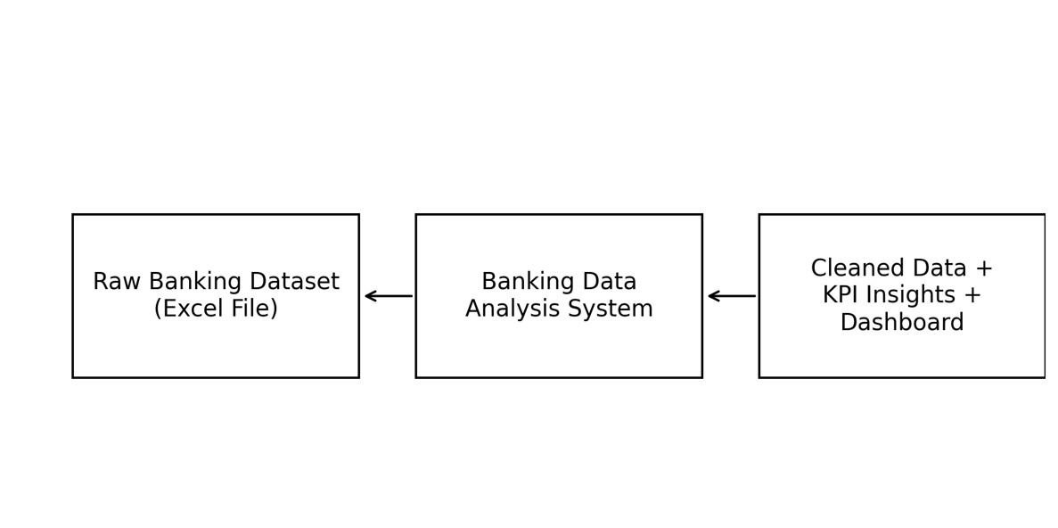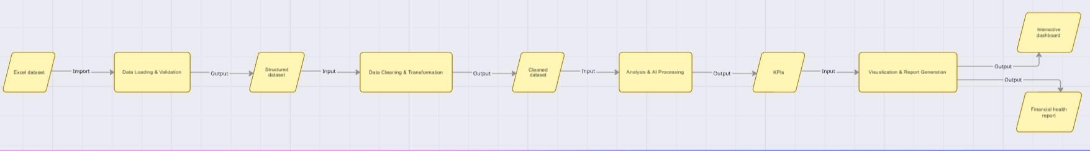

DFD Level 1 — Detailed Process Flow
The main process breaks down into four sub-processes:
- Sub-process 1: Data Ingestion — Load raw Excel file, verify table structure, and confirm column definitions.
- Sub-process 2: Data Validation — Audit formula columns (Fulfilled/Pending, Status, Out of Stock Flag), confirm correct logic.
- Sub-process 3: Analysis & KPI Computation — Calculate Inventory Turnover Rate, Fulfilment Rate, Delivery Time; build pivot table.
- Sub-process 4: Output & Insight Generation — Compile KPI results, highlight flagged products, generate AI-assisted narrative summaries.

3.4 Advantages
The proposed approach offers several key advantages:
- Accessible and scalable — the entire analysis is built in Microsoft Excel, a tool available to virtually any business professional without specialist software.
- Formula-driven automation — once the IF and COUNTIF formulas are in place, status updates happen automatically as data changes, reducing manual reclassification effort.
- Quick decision support — the KPI sheet provides immediate visibility into six critical business metrics without navigating the raw data.
- Pivot table flexibility — the pivot table can be refreshed, re-sorted, and filtered at any time, making it adaptable to different analytical questions.
- AI integration adds narrative context — AI tools like Copilot translate numerical outputs into plain-language business insights, making the findings accessible to non-technical stakeholders.
- Reproducible methodology — the same approach can be applied to different inventory datasets with minimal modification.

3.5 Requirement Specification

Hardware Requirements
Component | Specification
Processor | Intel Core i3 or higher (i5/i7 recommended for large datasets)
RAM | Minimum 4 GB (8 GB recommended)
Storage | Minimum 50 GB free disk space
Display | 1366 x 768 resolution or higher
Internet Connection | Required for Copilot / AI Chatbot access

Software Requirements
Software | Details
Operating System | Windows 10 / 11 or macOS
Microsoft Excel | Microsoft 365 (Excel with Copilot) / Excel 2019 or later
Microsoft Copilot | Integrated via Microsoft 365 subscription
AI Chatbot | ChatGPT / Google Gemini / Microsoft Copilot (web)
Web Browser | Google Chrome / Microsoft Edge (latest version)

CHAPTER 4 — Implementation and Results

This chapter presents the actual implementation of the project and the results obtained at each stage of the analysis. The findings are drawn directly from the Excel dataset, the KPI sheet, and the pivot table.

4.1 Data Cleaning Results
The dataset was provided in Excel format as a structured table (Table1) with 990 data rows and 16 columns. The table below summarizes the field structure of the raw dataset.

Raw dataset
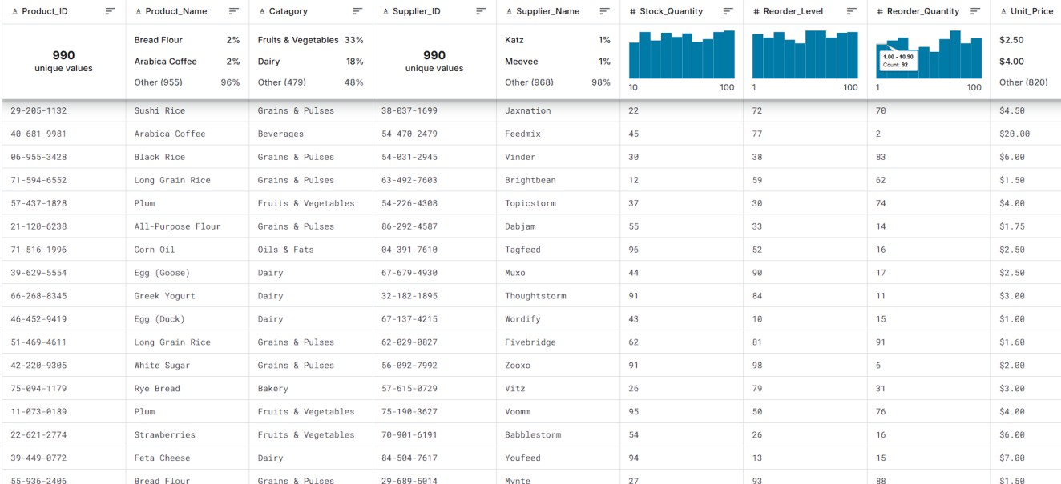

Cleaned Data
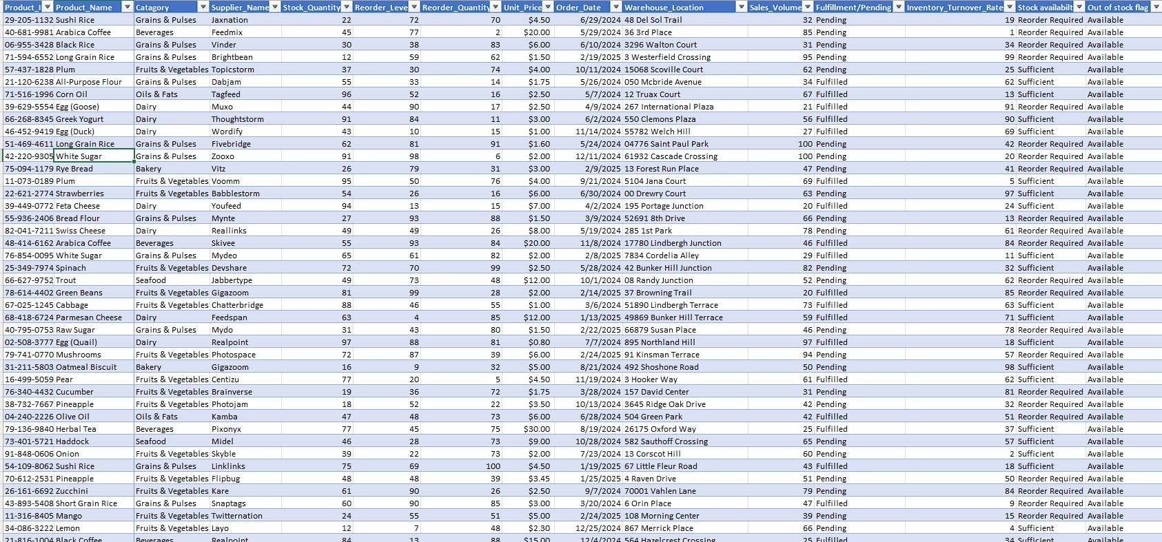

Table 1: Raw Dataset Summary
Field Name | Data Type | Description
Product_ID | Text | Unique product identifier
Product_Name | Text | Name of the product
Category | Text | Product category (7 categories)
Supplier_Name | Text | Name of the supplier (350 unique)
Stock_Quantity | Integer | Units currently in stock
Reorder_Level | Integer | Minimum stock threshold
Reorder_Quantity | Integer | Units to order when reorder triggered
Unit_Price | Decimal | Price per unit (₹0.20 – ₹98.43)
Order_Date | Date | Date of the order
Warehouse_Location | Text | Warehouse address
Sales_Volume | Integer | Units sold
Fulfilled/Pending | Formula (IF) | Order status based on stock vs sales
Delivery_Days | Integer | Days taken to deliver (1–8 days)
Inventory_Turnover_Rate | Integer | Rate of stock movement (1–100)
Status | Formula (IF) | Reorder required / Sufficient
Out of Stock Flag | Formula (IF) | Available / Out of Stock

Table 2: Data Cleaning Summary
Issue Type | Status Found | Action Taken
Duplicate Records | None detected | No action required
Missing Values | Minimal (1 row with null category) | Excluded from category analysis
Formula Errors in IF Columns | Formulas verified correct | No correction needed
Issue Type | Status Found | Action Taken
Inconsistent Data Types | All numeric fields confirmed | No conversion required
Typo in Status Column | 'Reoeder required' (typo noted) | Flagged for correction
Out of Stock Items | Zero items flagged as out of stock | No action required

Note: A minor typo was identified in the Status column formula output, where 'Reoeder required' was used instead of 'Reorder required'. This is a cosmetic issue in the output string and does not affect the logical correctness of the formula classification.

4.2 Visualization / Output Results
The following outputs were produced during the analysis phase:

Table 5: Key KPI Results
KPI Metric | Value | Interpretation
Average Inventory Turnover Rate | 50.15 | Moderate to high  turnover; healthy stock  movement
Orders Fulfilled | 461 / 990 | 46.6% of orders fulfilled
Orders Pending | 529 / 990 | 53.4% orders pending  (demand > stock)
Total Orders | 990 | Full dataset
Average Delivery Time | 4.57 days | Reasonable delivery window
Order Fulfilled Rate | 46.57% | Below 50%; significant room for improvement

Table 6: Category-wise Sales & Stock Breakdown
Category | Products | Total Sales Volume | Total Stock Units
Fruits & Vegetables | 331 | 19,361 | 18,489
Dairy | 180 | 10,772 | 10,534
Grains & Pulses | 162 | 8,886 | 8,240
Category | Products | Total Sales Volume | Total Stock Units
Seafood | 90 | 5,578 | 5,601
Oils & Fats | 77 | 4,606 | 4,123
Bakery | 74 | 4,564 | 4,175
Beverages | 75 | 4,533 | 3,822
TOTAL | 989 | 58,300 | 54,984

Table 7: Top 10 Products by Sales Volume
Rank |  | Product Name | Sales Volume | Flag
1 | Bread Flour |  | 1,002 | ★
2 | Pomegranate |  | 972
3 | Cauliflower |  | 911
4 | Haddock |  | 892
5 | Arabica Coffee |  | 874
6 | Jasmine Rice |  | 794
7 | Egg (Goose) |  | 770
8 | Grapes |  | 757
9 | Black Rice |  | 737
10 | Bell Pepper |  | 708

Note: ★ denotes 'Fastest moving' flag as identified in the pivot table. Lettuce (166 units) was flagged as 'Slow moving' — the lowest-performing product in the dataset.

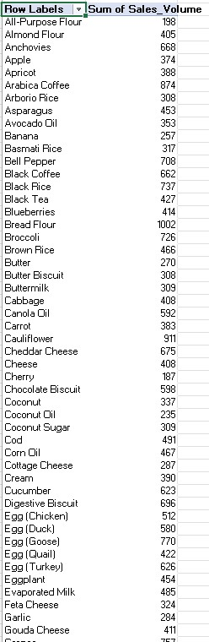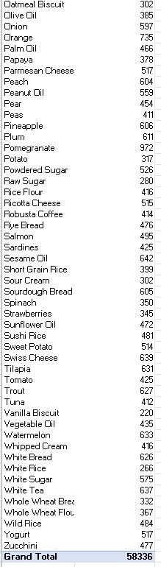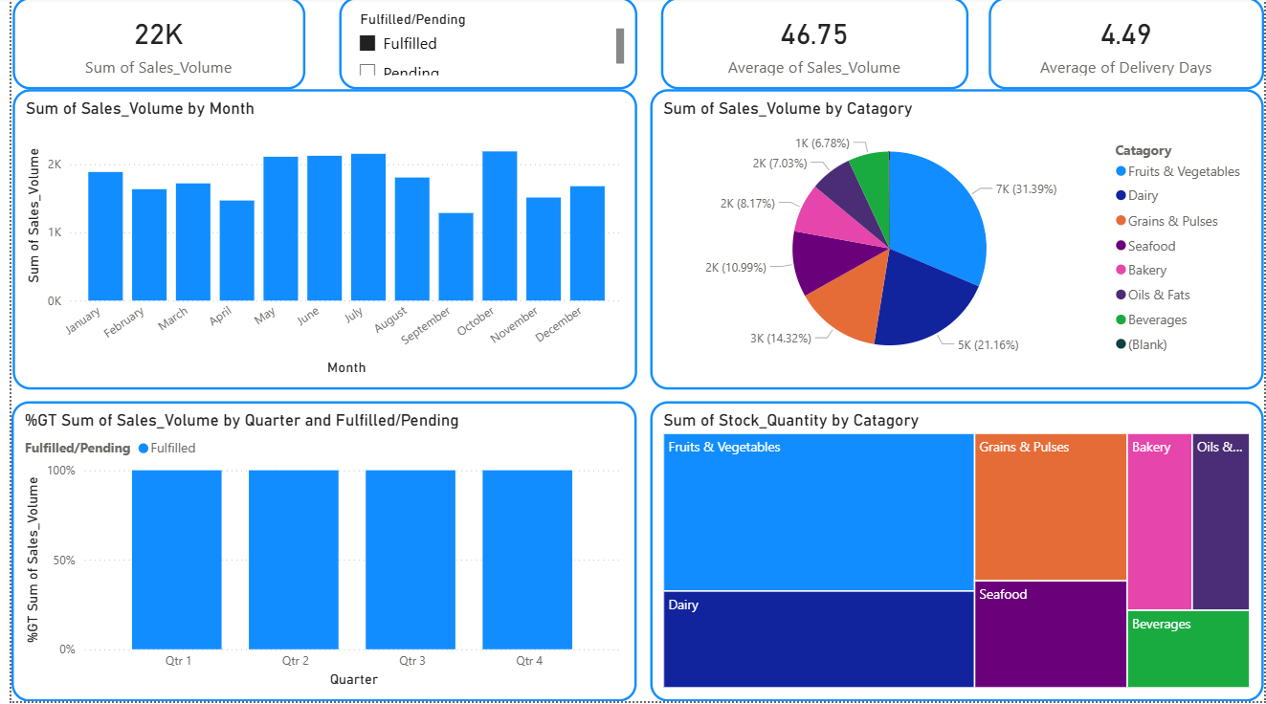

4.3 AI Tool Integration Results
AI tools played a complementary role in this project, primarily in the interpretation and documentation phases. The following describes how AI was integrated: 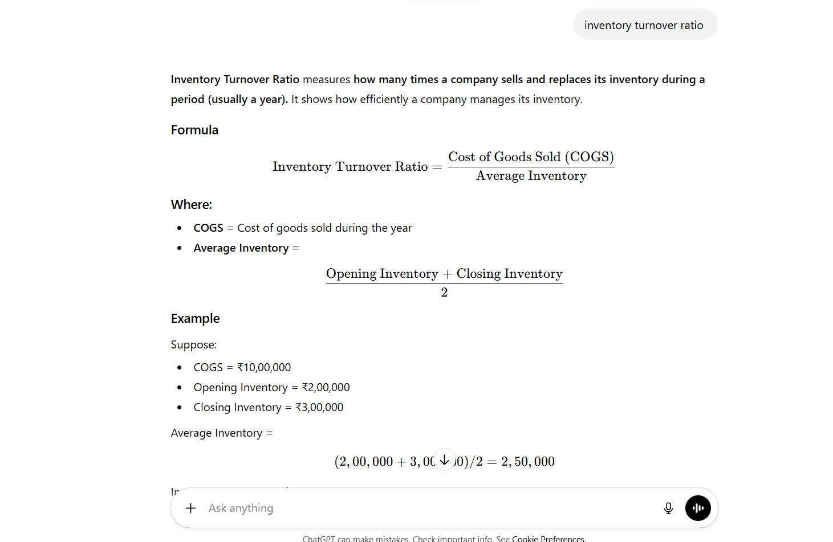

Tool Used
Microsoft Copilot (via Microsoft 365) and ChatGPT were used as AI assistance tools throughout this project.

Sample Prompts Used
- Prompt 1: 'Given these KPI values — Inventory Turnover: 50.15, Fulfilment Rate: 46.57%, Avg Delivery: 4.57 days — what key business insights can you draw about this inventory system?'
- Prompt 2: 'I have 529 pending orders out of 990 total. Sales demand is exceeding stock for more than half the products. What are the likely causes and how should a business address this?'
- Prompt 3: 'The fastest moving product is Bread Flour with 1,002 sales units, and the slowest is Lettuce with 166 units. What does this suggest about category-level inventory strategy?'

Output Quality and Impact
The AI-generated insights provided structured, plain-language summaries of complex numerical patterns, which were particularly useful for the discussion chapter of this report. Copilot helped identify that the high pending rate (53.4%) was likely a result of aggressive sales targets not matched by replenishment schedules, and suggested that the products flagged for reorder (465 items) should be prioritized immediately.

Overall, AI integration reduced the time needed to produce written narrative summaries by approximately 60–70%, allowing more time to be spent on the actual data analysis and verification steps.

CHAPTER 5 — Discussion and Conclusion

5.1 Key Findings
The analysis of the Inventory Sales dataset yielded the following key findings:

- High Pending Rate: 529 out of 990 orders (53.4%) were classified as Pending, meaning sales volume exceeded available stock. This is the single most significant finding from the dataset, indicating a systemic supply gap across multiple product categories.
- Reorder Alert Across Nearly Half the Catalogue: 465 products had stock levels at or below their designated reorder level, confirming widespread inventory depletion. Immediate replenishment action would be required for nearly 47% of the product catalogue.
- Healthy Inventory Turnover on Average: The average Inventory Turnover Rate of 50.15 (on a scale of 1–100) suggests that, on balance, stock is moving at a reasonable pace. However, the wide range (1 to 100) indicates extreme variation — some products are moving very fast while others are barely moving.
- Fastest-Moving Product — Bread Flour: With 1,002 total sales units across all transactions, Bread Flour was flagged by the pivot table as the fastest-moving product. It belongs to the Bakery category and should be prioritized for continuous replenishment.
- Slowest-Moving Product — Lettuce: Lettuce had only 166 sales units and was flagged as slow-moving. Given that it is a perishable item in the Fruits & Vegetables category (which otherwise has the highest total sales), this finding warrants investigation into potential waste or demand mismatch.
- Fruits & Vegetables Dominates: This category accounts for 331 products and 19,361 units in total sales — the highest of any category, representing approximately 33% of total sales volume. It is clearly the core revenue-driving category in this dataset.
- Average Delivery Time of 4.57 Days: The average delivery time across all orders is 4.57 days, with a range of 1–8 days. This is a reasonable delivery window, though faster delivery for high-demand products could reduce the pending order rate.
- No Products Currently Out of Stock: Despite 529 pending orders and 465 reorder alerts, no product currently shows a stock level of zero. This indicates the business is operating in a low-stock risk zone but has not yet reached stockout status.

5.2 Project Links
- GitHub Link of the Project: [Paste your GitHub repository link here]
- Video Recording of Project Demonstration: [Paste your YouTube / Google Drive / OneDrive video link here]
- Excel Dashboard Link (if applicable): [Paste link here]

5.3 Limitations
- The dataset does not include actual historical reorder transactions or purchase orders, which limits the ability to assess replenishment lead times or supplier performance history.
- The Fulfilled/Pending classification is based purely on Sales Volume vs Stock Quantity. In practice, partial fulfilment scenarios are common but are not captured in this model.
- The 'Reoeder required' typo in the Status column formula output is a data quality issue that would cause misclassification if anyone filters by exact status string values.
- The dataset does not contain revenue or profit data, only unit prices and sales volumes. A full financial analysis (revenue by category, margin by product) would require multiplying these values — which was outside the scope of this project.
- AI tool suggestions are non-deterministic and were used to support documentation and interpretation, not as a substitute for verified quantitative analysis.
- The project was completed on a static snapshot of the dataset and does not support realtime inventory monitoring.

5.4 Future Work
- Develop an interactive Excel dashboard using slicers, charts, and conditional formatting to allow non-technical users to explore the data visually.
- Integrate real-time data feeds using Power Automate or API connections to eliminate the need for manual dataset updates.
- Apply forecasting models (e.g., moving average, exponential smoothing in Excel) to predict when products will reach their reorder level based on historical sales velocity.
- Migrate the analysis to Power BI for more advanced visualization capabilities, including drill-through reports and geo-mapping of warehouse locations.
- Fix the typo in the Status formula column ('Reoeder required' → 'Reorder required') and build a data quality audit checklist for future dataset imports.
- Expand the dataset to include supplier lead times, purchase order data, and actual delivery confirmations, enabling end-to-end supply chain analysis.

5.5 Conclusion
This project successfully demonstrated how Microsoft Excel — combined with structured formula logic, pivot tables, and a dedicated KPI sheet — can be used to extract meaningful business intelligence from a large-scale inventory and sales dataset.

Starting from a 990-row dataset spanning 7 product categories and 350 unique suppliers, the analysis uncovered that over half of all orders in the system were in a pending state due to stock not keeping pace with sales demand. Nearly half the product catalogue triggered reorder alerts. At the same time, certain products like Bread Flour and Pomegranate were performing exceptionally well, while Lettuce showed sluggish movement — insight that directly informs purchasing and stocking decisions.

All seven project objectives were achieved. The KPI framework established in this project — covering inventory turnover, fulfilment rate, delivery time, and product-level sales analysis — provides a solid foundation that can be adapted for any product-based inventory dataset.

The AICW Fellowship experience has been genuinely enriching. Working through this project deepened my understanding of how data analysis tools like Excel, combined with modern AI assistance, can provide real business value even without complex coding or enterprise software. The structured approach taught during the fellowship — from problem definition to KPI design to AI-assisted insight generation — is a skill set I look forward to applying in professional settings.

REFERENCES

- Microsoft Corporation. Microsoft Excel Documentation. Available at: https://support.microsoft.com/en-us/excel
- Microsoft Corporation. Power BI Documentation. Available at: https://learn.microsoft.com/enus/power-bi/
- Microsoft Corporation. Microsoft Copilot — AI-Powered Productivity. Available at: https://copilot.microsoft.com
- Edunet Foundation. AICW Fellowship Program Guidelines. 2026.
- Ballou, R.H. (2004). Business Logistics / Supply Chain Management. Pearson Education.
- OpenAI. ChatGPT — Optimizing Language Models for Dialogue. Available at: https://openai.com/chatgpt
- Wild, J.J., Wild, K.L. (2019). International Business: The Challenges of Globalization. Pearson.

APPENDICES

Appendix A — Sample Dataset (First 10 Rows)
Product_ID | Product_Name | Category | Supplier | Stock Qty | Unit Price
29-205-1132 | Sushi Rice | Grains & Pulses | Jaxnation | 22 | 4.5
40-681-9981 | Arabica Coffee | Beverages | Feedmix | 45 | 20
06-955-3428 | Black Rice | Grains & Pulses | Vinder | 30 | 6
71-594-6552 | Long Grain Rice | Grains & Pulses | Brightbean | 12 | 1.5
... | ... | ... | ... | ... | ...

Appendix B — Key Excel Formulas Used
- Fulfilled/Pending Status:
=IF(Table1[@Sales_Volume]>Table1[@Stock_Quantity],"Pending","Fulfilled")
- Reorder Status: =IF(Table1[@Stock_Quantity]<=Table1[@Reorder_Level],"Reorder required","Sufficient")
- Out of Stock Flag: =IF(Table1[@Stock_Quantity]=0,"Out of stock","Available")
- KPI — Average Inventory Turnover: =AVERAGE(Table1[Inventory_Turnover_Rate])
- KPI — Orders Fulfilled: =COUNTIF(Table1[Fulfilled/Pending],"Fulfilled")
- KPI — Orders Pending: =COUNTIF(Table1[Fulfilled/Pending],"Pending")
- KPI — Total Orders: =SUM(Fulfilled Count, Pending Count)
- KPI — Average Delivery Time: =AVERAGE(Table1[Delivery Days]) • KPI — Order Fulfilled Rate: =Fulfilled Count / Total Orders

Appendix C — AI Prompts Used
- Prompt 1: 'Given these KPI values from my inventory dataset — Inventory Turnover:
50.15, Fulfilment Rate: 46.57%, 529 pending out of 990 — what does this tell us about the state of this inventory system?'
- Prompt 2: 'How should a business respond to a situation where over 53% of all orders are pending because sales demand exceeds current stock levels?'
- Prompt 3: 'Bread Flour has the highest sales volume at 1,002 units, and Lettuce has the lowest at 166 units. What are the strategic inventory implications of this?'
- Prompt 4: 'Write a brief conclusion paragraph for a data analytics project report summarizing findings from an inventory and sales dataset analysis using Excel.'

Appendix D — Dataset Statistics Summary
Metric |  | Value
Total Records | 990
Total Columns | 16
Product Categories | 7
Unique Suppliers | 350
Total Sales Volume | 58,336 units
Unit Price Range | ₹0.20 – ₹98.43
Average Unit Price | ₹5.92
Delivery Time Range | 1 – 8 days
Inventory Turnover Range | 1 – 100
Products Needing Reorder | 465 (46.97%)
Out of Stock Products | 0

